Project Development Phase

|  |  |
| --- | --- |
| **Team ID** | **PNT2022TMID41669** |
| **Project Name** | **IoT Based Safety Gadget for Child Safety Monitoring and Notification** |

SPRINT I:

1. **ACCOUNT CREATION:**

Link: https://node-red-cdaue-2022-11-17.eu-de.mybluemix.net/signup

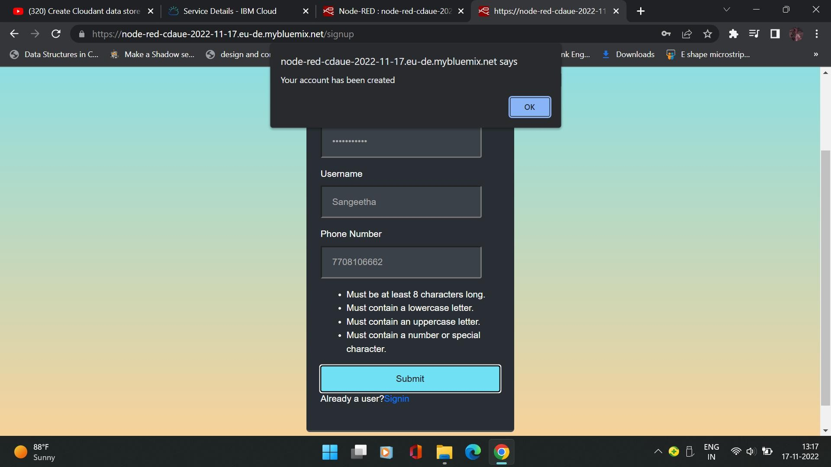

1. **SIGN IN PAGE:**

